Crypto Master

Let’s say you have passed on the other side of the dangerous floor. Now the only thing that separates you from the real deal is the darn safe lock. Till now you had instructions for each task but not this time … this time your uncle have forgotten to leave you the combination for the safe so you have to figure out a way to unlock it! After hours of searching for any clue, the only thing you find is a sign on the side of the safe saying: “The numbers of the code are in increasing order”. Yeah, you guessed that one - brute-force! Or maybe you haven’t … anyway, time is all yours to have some fun now!

Your task is to find a brute-force algorithm to unlock the safe. You will receive a sequence of numbers, which represent the locker. This sequence forms a circle, so the last number is just before the first one and the first number is right after the last one - you have no ending of the sequence.

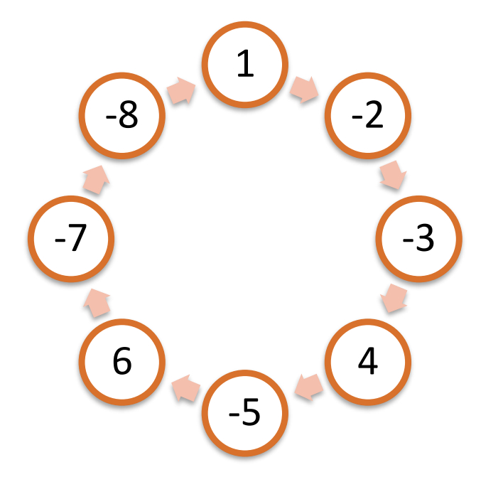

You can start from any number in the circle and move to another one and choose any size for the step from the range below. The direction must be from left-to-right. There are four rules you should keep:
• You should always jump to a larger number than the one you are currently on
• You cannot jump on the same number more than once per try
• The size of the jumping step can vary in the range 1 - the size of the sequence of numbers but must be constant within a single try
• The size of the step should be constant within a single try

Example
In the sample above, the best route is -7, -5, -3, 1 with length 4 and step 6.
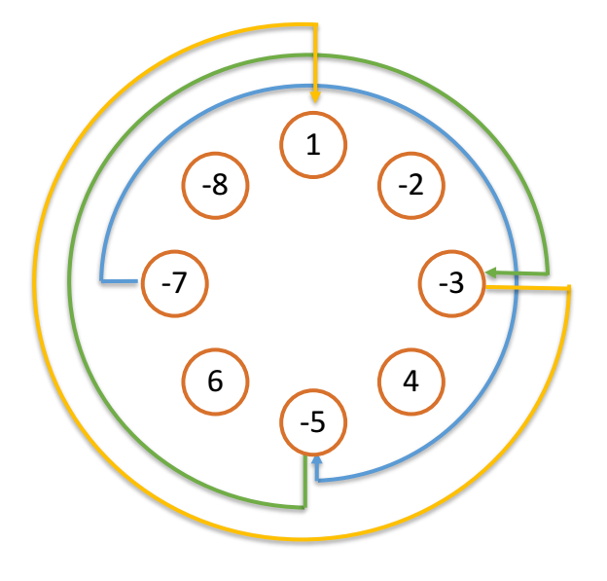

Input
The input data should be read from the console.
On the first line you will be given the numbers separated with “,” (comma and space).

Output
The output data should be printed on the console. You should print the count of longest sequence, which you have found.

Constraints
• The count of numbers will be between 1 and 2500 inclusive.
• Each of the number will be between -1000 <= n <= 1000
• Allowed working time for your program: 0.2 seconds. Allowed memory:16 MB.

Examples
Input | Output
1, -2, -3, 4, -5, 6, -7, -8 | 4
1, 2, 3, 4, 5, 6, 7, 8, 9, 10, 0 | 11
1, 1, 1 | 1

